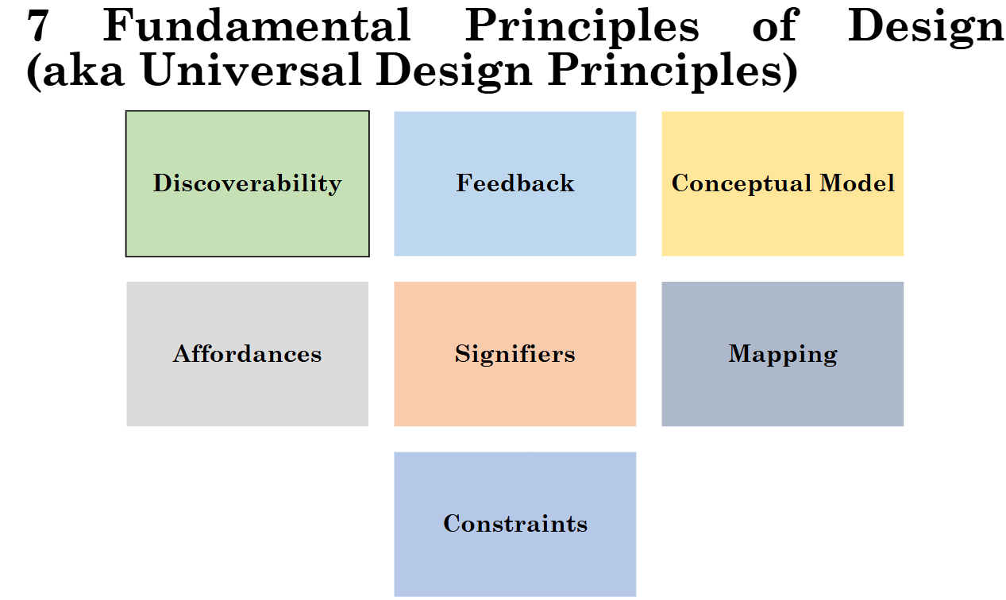

g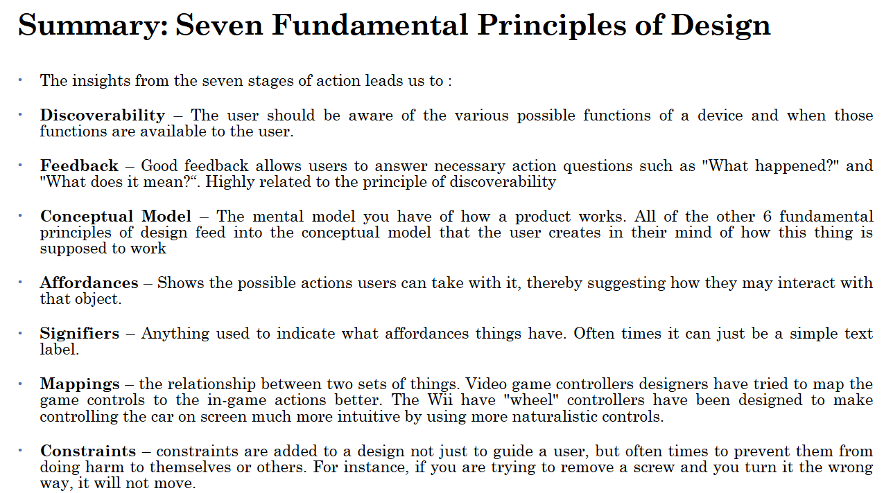

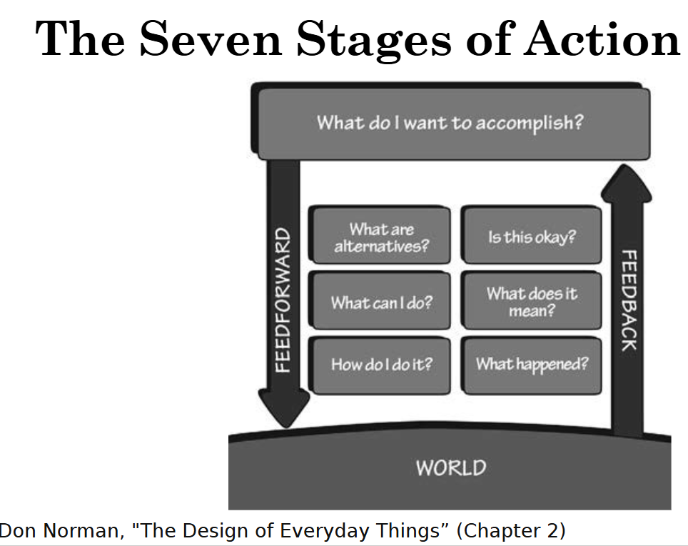

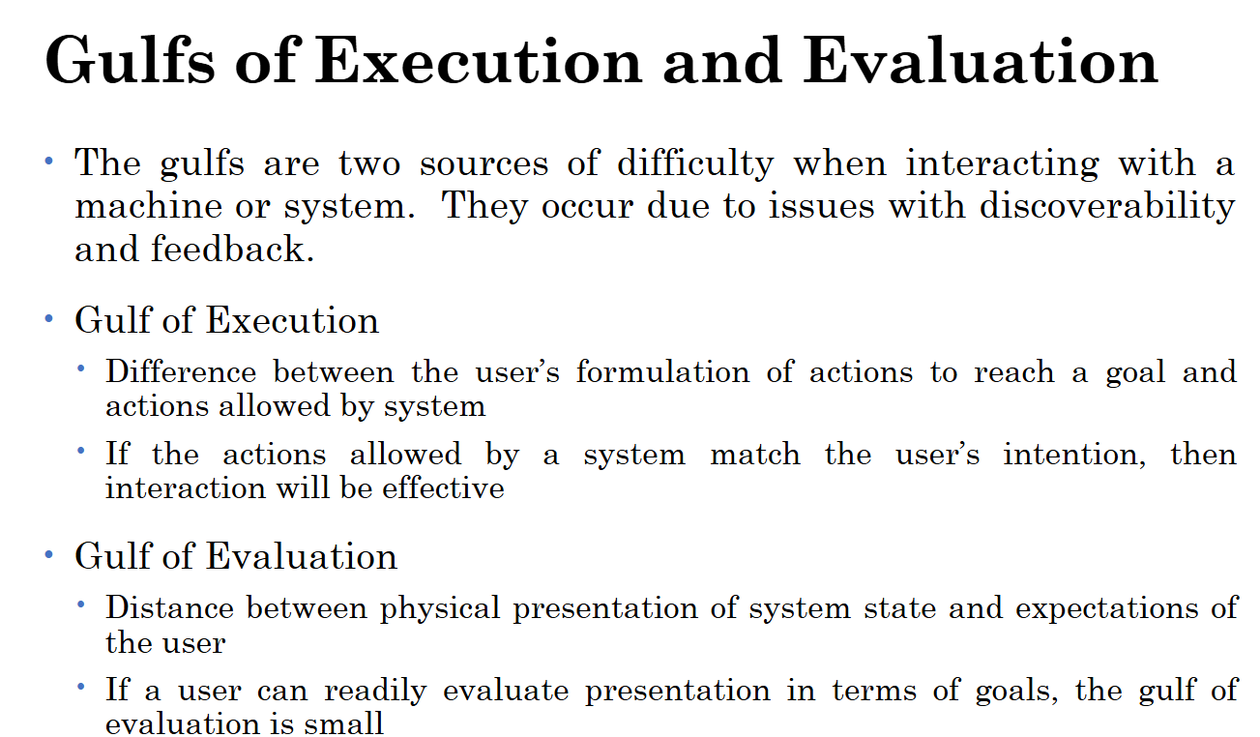

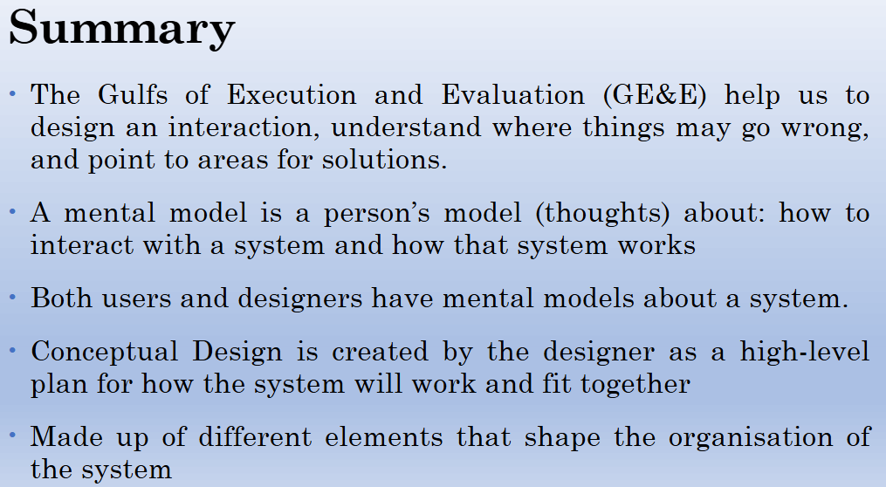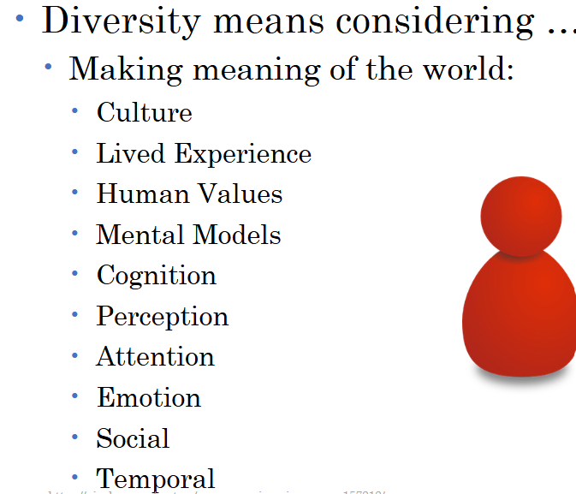

Low fidelity (Basic) -> High fidelity (Complex/more complete)

**Mental Model –** The mapping between the inputs and outputs of a system.

**Control –** Utilising multiple systems to achieve a goal.

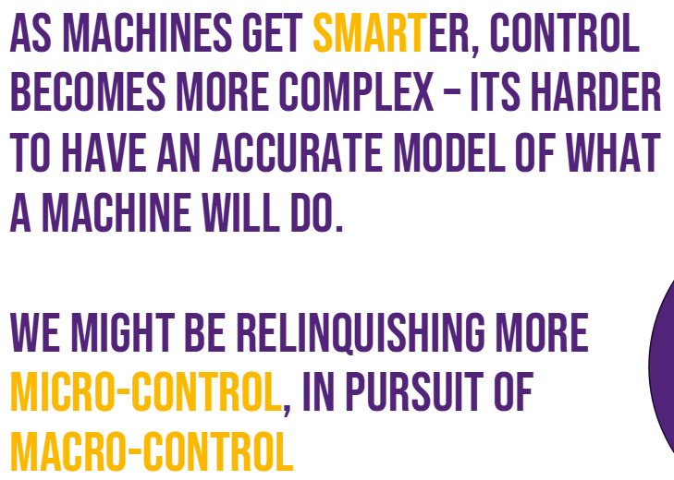

Millers law: 7 items in memory at a time.

Gestalt Theory: Humans recognise patterns and shapes to fill in the gaps ( information is perceived as wholes rather than disparate parts which are then processed summatively)

Hicks law:

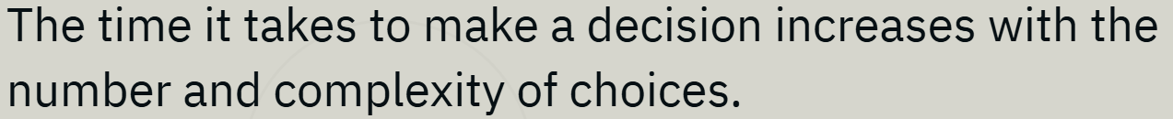

Fitt’s law:

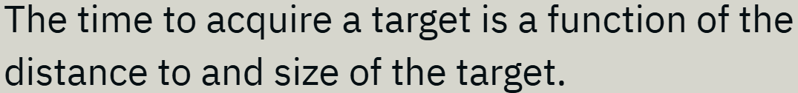

**User based evaluations**

System Usability Scale (SUS) = Places a quantitative score on the usability of a system using 10 standardised questions.

Technology Acceptance Mode (TAM) = Analyses perceived usefulness against perceived ease of use.

Time on Task: Measuring the time to complete task, mean time to failure, average time on task.

Think Aloud: Ask client to verbalise all thoughts whilst completing a given task.

Two variations: specific task or open-ended task.

Data analysis: Analysis data such as interviews, focus groups, questionnaires, direct observation of fields or controlled environment, indirect observation.

**Expert evaluations**

**(Nielsens)**

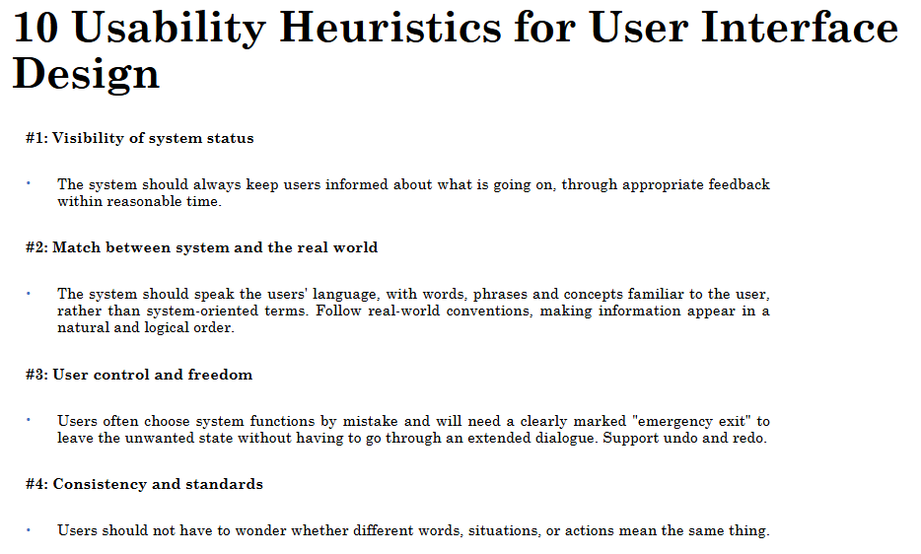

Cognitive walkthrough: Go through Normans seven stages of action.



